Hermes Development Log
Saturday 12 March
Continuing on from yesterday’s work with imgui and native android application glue code. Tested on a VM and on my phone. Now working on interface design with Inkscape:
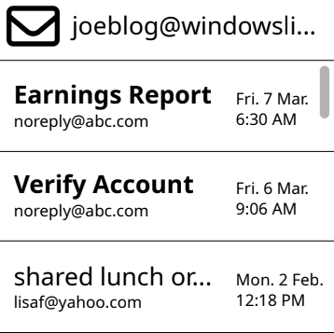
At around 2PM, got a build with a title and will move the code out into a class and instantiate it from the main function. Next, will try implementing the scrolling list view.
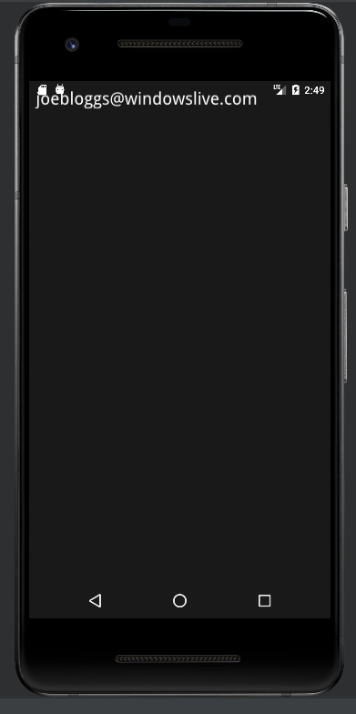
Work has paused.

